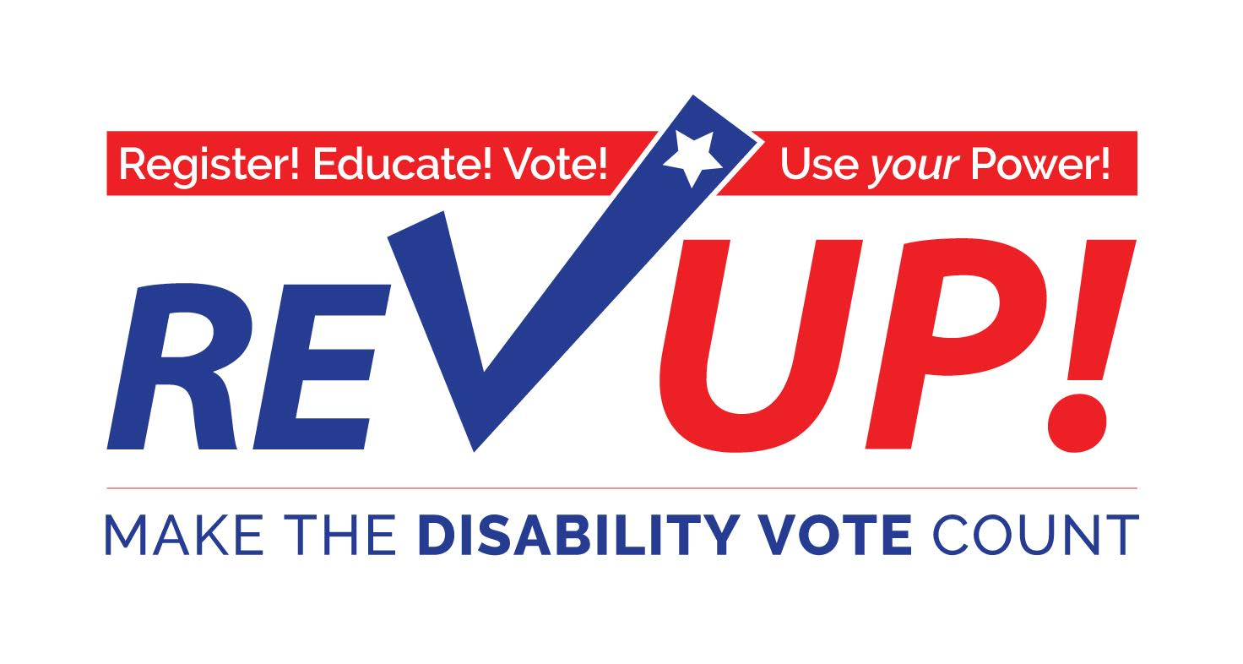

**MARYLAND TOOLKIT**

Presented by

**Independence Now**

**Disability Rights Maryland**

*Special thanks to The Texas Disability Project for creating the initial Toolkit*

**The American Association of People with Disabilities**

[www.aapd.com/REVUP](http://www.aapd.com/REVUP)

Dear Disability Rights Advocates:

There are approximately 57 million Americans with disabilities. People with disabilities represent 15% of the total voting population.

However, in the 2012 election:

* 57.2% of people with disabilities ***DID NOT VOTE*!**
* 30% of people with disabilities said they wanted to vote but were unable to

− 72% of polling places WERE NOT ACCESSIBLE!

***The November 8th election will be one of the most important elections in over a decade.***

The disability community—people with disabilities, family members, attendants, providers, professionals, advocates and supporters—has a major stake in the outcome of this election.

The ***Disability Vote*** can make a difference on issues such as:

* Adequate funding and coverage for Medicaid acute and long term services and supports.
* Waiting lists for home and community services.
* Integrated employment at no less than minimum wage.
* Accessible, affordable, integrated housing.
* Any many more issues!

We need your help to register voters, help voters understand the voting process, and get voters to the polls and overcome any barriers to exercising the right to vote.

Use this toolkit to:

* ***Register! Educate! Vote!***
* ***Use your Power!***

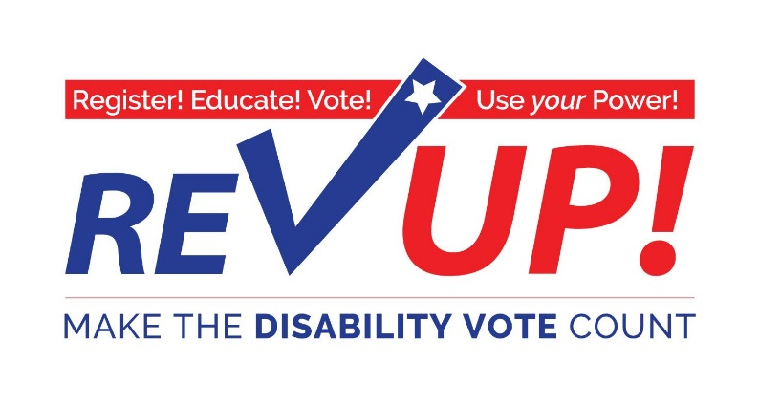

***Marylanders with disabilities CAN influence the outcome  
 of the General Election in November***

**‘More than any time in memory:**

* Elected leaders and political candidates are recognizing the 57 MILLION Americans with disabilities—from birth to advanced age—as a powerful, important constituency
* Issues important to people with disabilities must be part of the platform for any candidate running for public office.

**Join thousands of Americans with disabilities in this important and historic effort!**

***Don’t Mourn…Organize, Register, and VOTE!  
Onward to November 8, 2016! Make the DISABILITY VOTE Count!***

**For more information:**

**Disability Rights Maryland**

[**www.DisabilityRightsMD.org**](http://www.DisabilityRightsMD.org)

**(410) 727-6352, ext. 2507**

**Independence Now**

[**www.innow.org**](http://www.innow.org)

**(240) 898-2183**

**How to Join the Maryland REV UP 2016 Campaign**

**and**

**Increase the Power of the Disability Vote:**

REV UP 2016 encourages individuals to take these steps:

**Step 1** Review the Maryland Rev Up Toolkit. The Toolkit includes information and resources to help people with disabilities and supporters register and vote. For more information about REV UP 2016 go to [www.aapd.com/REVUP](http://www.aapd.com/REVUP)

**Step 2:** Make sure YOU are registered to vote***!***

**Step 3:** Distribute information and registration forms to your friends for them to complete to ensure that they are registered to vote.

**Step 4:** Schedule a voter registration and training presentation with Disability Rights Maryland (DRM). Contact Tracy Wright, Voting Advocate at DRM, by phone at 443-690-2603 or by email at [tracyw@DisabilityRightsMD.org](mailto:tracyw@DisabilityRightsMD.org)

**Step 5:** Let people know about the Voter Hotline at Disability Rights Maryland and report a voting concern by calling 443-692-2492 or emailing at [voting@DisabilityRightsMD.org](mailto:voting@DisabilityRightsMD.org)

**Step 6:** Use the *Polling Place Survey* (at the end of this Toolkit) when you vote to help us collect information about the accessibility of polling places nationally.

**Important pointers for talking to people about voting:**

|  |  |
| --- | --- |
| **DO:** | **DO NOT:** |
| * Encourage family, friends and others to register to vote and, if eligible, to request a ballot by mail. * Explain and emphasize the importance of the disability vote and the rights of individuals with disabilities to vote. * Encourage friends, colleagues, and family members to request a *REV UP 2016 Toolkit* from [www.aapd.com/REVUP](http://www.aapd.com/REVUP) | * Recommend, endorse, or encourage support for one candidate or party over another. * Tell the people you’re registering which party to register under or who to vote for. * Coordinate activities with a candidate or campaign or political party * Target your registration efforts toward any particular ideological group, party, or issue. |
|  | |
| **Guide for talking to others about voter registration and *REV UP 2016* :**  **Ask the question, “Are you registered to vote?”** | |
| **If the answer is NO:** | **If the answer is YES:** |
| **Would you like register? It’s easy!**   * Provide them with the registration form. * Forms are available for download from the Maryland State Board of Elections website at <http://www.elections.maryland.gov/>     **Would you like assistance to complete the registration form?**   * You may assist them in completing the registration form.   **You need to mail the registration form to the County Board of Elections**.   * The address for the County Board of Elections Office is on the voter registration form or available on the State Board of Elections website * You may assist them in mailing in the form.   **Voter Registration Forms must be sent in to the County Board of Elections by October 18, 2016.**  **Remind them that General Election day is November 8, 2016.** | **Do you need to apply by absentee ballot?  It’s easy!**   * Provide them with the information about voting by absentee ballot. * Applications can be downloaded from the State Board of Elections website at <http://www.elections.maryland.gov/>   **Would you like assistance to complete the application for an absentee ballot?**   * You may assist them in completing the absentee ballot application.   **The applicant needs to mail the application to the County Board of Elections.**  **Absentee ballots must be submitted to the County Board of Elections by:**   * Tuesday, November 1, 2016, if the voter want to receive your ballot by mail or fax * Friday, November 4, 2016, if the voters wants to download the ballot from the State's website   **Ballots must be mailed or delivered to the County Board of Elections Office by November 8, 2016.** |

### 2016 Voting Dates to Remember

**NOVEMBER GENERAL ELECTION**

* October 18, 2016: Last day to register to vote in the General Election
* Early voting: Thursday, October 27, 2016 through Thursday, November 3, 2016 from 8 am until 8 pm.
* Your request for an Absentee Ballot (vote by mail) must be received by:

Tuesday, November 1, 2016, if you want to receive your ballot by mail or fax

Friday, November 4, 2016, if you want to download your ballot from the State's website

* If you mail your Absentee Ballot, the envelope must be postmarked on or before Election Day and received by your local board of elections by November 18, 2016.
* ***November 8: Election Day!***

**Same Day Voter Registration during Early Voting**

Voters can also register to vote during early voting. The voter must go to an early voting center in the county where he or she lives and bring a document that proves where they live. This document can be an MVA-issued license, ID card, or change of address card, or paycheck, bank statement, utility bill, or other government document with the name and address of the voter.

**Your Vote Matters**

*Information for Individuals with Disabilities*

**You have the right to:**

* Vote by yourself and make your own choices.
* Get help from a person of your choice or an election worker.
* Use a physically accessible polling place and an accessible voting machine.
* Vote if you have a guardian, unless a court determines you cannot.

**Help America Vote Act (HAVA)**

The goal of the Help America Vote Act (HAVA), passed by Congress in 2002, is to make the voting process more inclusive and accessible so that more Americans will become registered voters and participate in elections.

Disability Rights Maryland (DRM) is the Protection & Advocacy agency designated by HAVA to help ensure accessible voting in Maryland. Specialists on staff can answer questions, respond to legal violations, and troubleshoot problems related to your voting rights. There are no costs for these services.

Disability Rights Maryland provides the following services related to voters with disabilities:

* Educates voters, election workers, and other persons involved in the voting process about the rights of people with disabilities.
* Provides information to people with disabilities about voter registration and the chance to register to vote.
* Provides advice about access to polling places on Election Day.
* Works with groups representing people with disabilities and other organizations in registering voters and surveying polling places for accessibility.
* Represents/advocates for individuals with disabilities who have complaints about the voting process.

**Who can register to vote?**

To register to vote, you must be:

* A U.S. citizen;
* A Maryland resident; and
* At least 16 years old*.

You cannot have been:

* Convicted of buying or selling votes;
* Under guardianship for mental disability and found by a court to be unable to communicate a desire to vote; or
* Convicted of a felony and currently serving a court-ordered sentence of imprisonment. (Effective March 10, 2016)

*You may register to vote if you are at least 16 years old but cannot vote unless you will be at least 18 years old by the next general election.

**How to register to Vote?**

* By mail: Request an application from your local voter registration office.
* In person: At the Motor Vehicles Administration, Public Library, Post Office, or any state agency that provides public assistance.
* Online: Use a computer and go to: <https://voterservices.elections.maryland.gov/OnlineVoterRegistration/InstructionsStep1>

**Different ways to vote.**

In addition to voting in person on Election Day, you can vote in these ways:

* ***By Absentee Ballot:*** Voters may apply for an Absentee Ballot.

To get an application for an Absentee Ballot and to check deadlines, go to: <http://www.elections.state.md.us/voting/absentee.html>

* ***Early voting:*** You can vote early in person at any polling place in your county. Early voting begins **Thursday, October 27, 2016 through Thursday, November 3, 2016** from 8 am until 8 pm. To find an early voting center near you, go to: <http://www.elections.state.md.us/voting/early_voting.html>
* ***On Election Day on November 8, 2016 at your local polling site.***

**Voting Rights & Accommodations**

**Voting Rights**

*I have the right:*

* To vote by myself and make my own choices.
* To get help from a person of my choice or an election worker.
* To a physically accessible polling place and the use of an accessible voting machine.
* To vote if I have a guardian, unless a court determines I cannot.

**You Have a Right to Election Accommodations on Election Day**  
*You can:*

* Ask to move to the front of the line or ask for a placeholder
* Bring someone to help you
* Have headphones to hear your ballot
* Have sample ballots in alternative format
* Have accessible parking
* Have temporary ramps
* Use a communication board
* Access an accessible ballot marking machine
* Use the accessible features of the ballot marking machine

**Voter Bill of Rights**

**As a Marylander Voter, you have the right to:**

**Vote in an accessible polling place**. Call your local board of elections or check on-line at <http://www.elections.state.md.us/voting/accessibility.html> to find out if your polling site is accessible to you. The on-line polling site locator will also confirm that you are registered. To request an accessible polling site contact your local board of elections by close of voter registration.

**Vote at an early voting center in the county where you live.** To find an early voting center near you, go to: <http://www.elections.state.md.us/voting/early_voting.html>

**Vote by Absentee Ballot.** Any registered voter may request to vote by Absentee Ballot. To get an application and to check deadlines, go to: <http://www.elections.state.md.us/voting/absentee.html>

**Cast a private and independent ballot**.

**Receive voting assistance if needed.** You may ask an election judge for help, or bring any other person to help you except your employer or union official.

**Mark a ballot on an accessible voting machine**. You may select a large print or high contrast ballot. You may also request an audio ballot, which requires the use of headphones and a keypad. The angle of the voting machines can also be adjusted for better access.

**Cast a ballot as long as you are in line when the polls close.**

**Vote a provisional ballot** if your name does not appear on the voter registration list or there is a question about your eligibility to vote.

**It is a good idea to bring identification with you*.*** Federal law requires that if you registered to vote by mail you must provide identification before voting for the first time in Maryland.

**Voter Hotline**

**To report voting concerns that may be related to a disability (such as access to a polling place, voter assistance, or problems using a voting machine) contact:**

**Disability Rights Maryland by phone at 443-692-2492; 800-233-7201, ext. 2492; TTY 410-235-5387 or by email at** [**voting@DisabilityRightsMD.org**](mailto:voting@DisabilityRightsMD.org)**.**

**Helpful Information for Maryland Voters with Disabilities**

*Take this along when you vote*

1. **To fix a problem at the polls, before you leave the polling place**
2. Talk to the head election judge, and if they can’t fix it, ask them to contact a county or state election official. If that doesn’t work,
3. Contact Disability Rights Maryland voter hotline at **443-692-2492** or by email at [voting@DisabilityRightsMD.org](mailto:voting@DisabilityRightsMD.org)
4. File a written complaint at your polling place.
5. **If you are under a guardianship…**
6. You still have the right to vote UNLESS your guardianship order says that the court has found that you are unable to communicate a desire to vote
7. **If you cannot sign your name…**
8. You have the right to tell the election judge who you are and tell another person to sign your name for you on the roster.
9. **You have the right to ask for help voting.**
10. Any person you choose can go with you into the voting booth – except an agent of your employer or union, or a candidate.
11. **It is against the law for anyone in the polling place to try to influence your vote.**
12. **You can ask someone to mark your ballot for you.**
13. It is against the law for them to mark the ballot for you if you cannot communicate to them who you want to vote for.
14. **You have the right to take a sample ballot into the voting booth with you.**
15. **If you make a mistake before submitting your ballot**

You may go back and make corrections, follow the directions on the voting system screen or ask for help from an election judge.

**A Basic Guide to Polling Place Accessibility**

This is a basic guide to accessibility to assist in identifying barriers and potential solutions to ensure access to voters with disabilities. Election officials should try to select fully accessible polling places and conduct the full Department of Justice accessibility survey.

**Parking and Drop-Off Areas**

* If parking is provided, at least one accessible parking spot that is nearest to the accessible entrance must be provided for every 25 regular parking spaces.
* The first accessible spot should be van accessible with an access aisle at least 8ft wide.
* Accessible parking spots should be relatively level and not have loose gravel or dirt.
* If drop-off area is provided, it should be level and have an access aisle that is at least 5ft deep and 20ft long where people can access entrance (near ramp if necessary).

***Solutions*:** Traffic cones can be used to mark accessible parking spaces and access aisles. Heavy duty mats can be used to level out uneven surfaces.

**Paths of Travel**

* There must be an accessible path from parking spot to entrance and voting area.
* Path must be at least 36 inches wide and free of steps or level changes more than ½ inch.
* If accessible path crosses traffic, a marked crosswalk should be used.
* Where path crosses curb, a curb cut or temporary ramp should be used.
* Ramps can’t be steep. For every 1 inch high, a ramp must be at least 12 inches long.

**Preventing Obstructions for Voters Who are Blind or Have Low Vision**

* People who are blind can easily run into objects that hang from above (ex. tree limbs), are open beneath (ex. staircases), or protrude from the side (ex. trophy cases).

***Solution:*** Place a barrier within 27 inches of the floor so cane can detect the obstruction.

**Entrance to Polling Place and Voting Area**

* Doorways must be at least 32 inches wide.
* Threshold must not be more than ¾ inches high at door and must be beveled on each side.
* No heavy doors.
* No slick, round door handles.

***Solutions*:** If door is too heavy to open easily, adjust door closer, disconnect operating arm, or prop door open on Election Day. If smooth round handles are on door, use temporary hardware or prop door open. If threshold is two high, use temporary threshold ramp on each side that is too high.

**Voting Area**

* An accessible voting machine on wheelchair accessible booth should be located along an accessible path in a location that ensures privacy.

**Call the Disability Rights Maryland Voting Hotline if you have any concerns on Election Day:**

* **(443) 692-2492;**
* **(800) 233-7201, ext. 2492;**
* **TTY 410-235-5387 or**
* **Email at voting@DisabilityRightsMD.org**

**Also, Visit** [**www.866ourvote.org**](http://www.866ourvote.org) **or call 1-866-OUR-VOTE (1-866-687-8683) to report any issues or concerns related to Election Day.**



**Polling Place Survey**

The REV UP Campaign would like to know if your polling place is accessible. Providing us information on the accessibility of your polling place may help resolve accessibility issues in the future. If you are interested in filling out this survey, please indicate the county and precinct information. You can also provide your contact information, although it is not required.

Thank you!

**State:** _________________________________________________________________________

**County:** _______________________________________________________________________

**Precinct:** ______________________________________________________________________

**Polling place address:** ___________________________________________________________

**Your Name (optional):** __________________________________________________________

**Your Phone/Email (optional):** ____________________________________________________

**Parking**

|  |  |  |  |  |
| --- | --- | --- | --- | --- |
| 1. | Was there at least one accessible parking space? | Yes | No | n/a |
| 2. | Was the accessible space marked by a visible sign (other than on the asphalt)? | Yes | No | n/a |
| 3. | Was the accessible parking area paved? | Yes | No | n/a |

**Entrance**

|  |  |  |  |  |
| --- | --- | --- | --- | --- |
| 4. | Is the walkway from parking to accessible entrance free of steps? | Yes | No | n/a |
| 5. | If there are steps or curbs, are there ramps provided? | Yes | No | n/a |
| 6. | Was there at least one accessible entrance? | Yes | No | n/a |
| 7. | Could you open all doors with a closed fist? | Yes | No | n/a |
| 8. | Were all doors wide enough for a wheelchair to pass through (32 inches)? | Yes | No | n/a |

**Voting Area**

|  |  |  |  |
| --- | --- | --- | --- |
| 9. Was there at least one accessible voting system provided? | Yes | No | n/a |
| 10. Were you able to easily use the voting machine’s accessibility features? | Yes | No | n/a |

If no, please explain:

______________________________________________________________________________

______________________________________________________________________________

______________________________________________________________________________

|  |  |  |  |  |
| --- | --- | --- | --- | --- |
| |  | | --- | |  |   11. Were you able to cast your vote privately and independently? | Yes | No | n/a |
| 12. If assistance or accommodations were requested, were poll workers helpful? (example: curbside voting, person of assistance, headphones) | Yes | No | n/a |

If no, please explain: __________________________________________________________________________

__________________________________________________________________________

___________________________________________________________________________

1. If your eligibility to vote was questioned, how did the poll worker handle the situation?

________________________________________________________________

______________________________________________________________________________

______________________________________________________________________________

1. What, if any, voter education or training have you received?

_______________________________________________________________

______________________________________________________________________________

______________________________________________________________________________

1. Any other comments:

_______________________________________________________________

_______________________________________________________________

**Please return this survey to:**

Disability Rights Maryland

Alyssa R. Fieo

1500 Union Ave, Suite 2000, Baltimore, MD 21211

[alyssaf@DisabilityRightsMD.org](mailto:alyssaf@DisabilityRightsMD.org)

#### Phone: (410) 727-6389, ext. 2507

Fax: (410) 727-6389